Welcome to Youth SVP Members’ Handbook

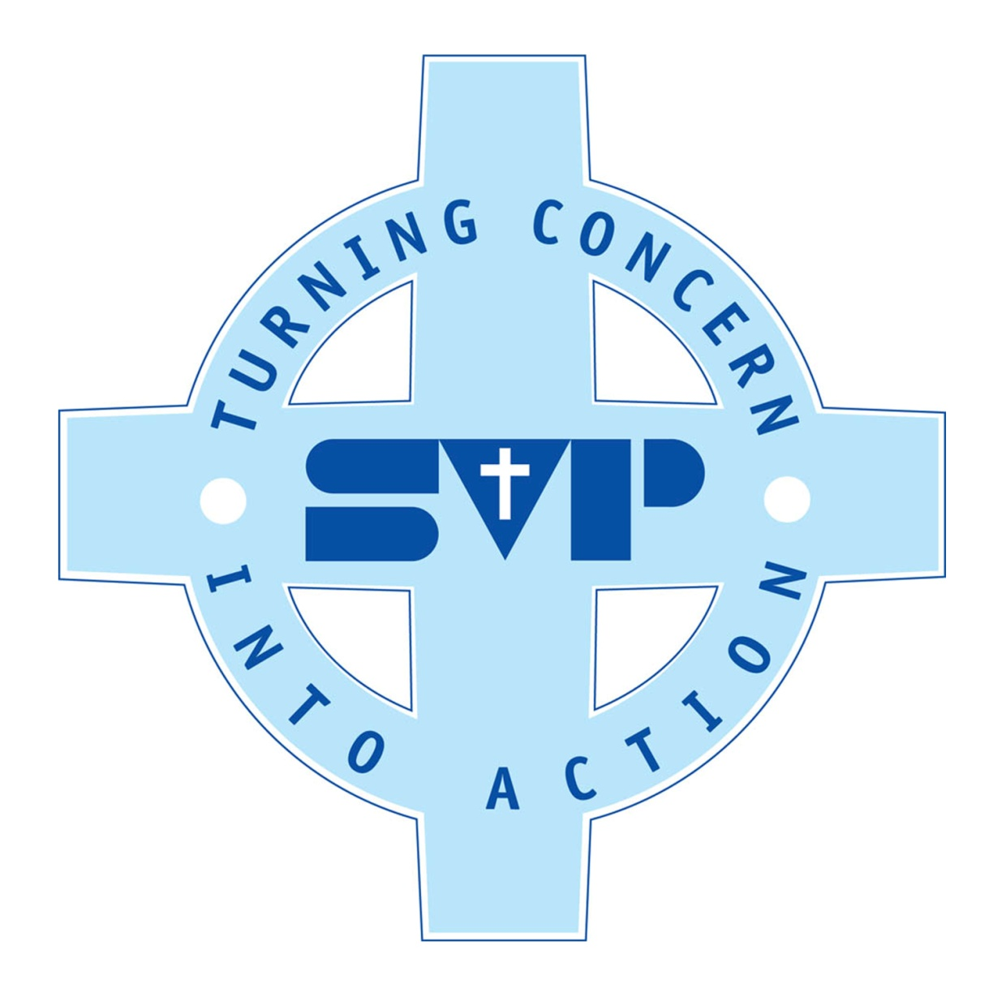

~ Lord, Jesus, help us through meeting together to deepen our Vincentian friendship, to bring your love to the suffering and deprived. Help us to be generous with our time our possessions and ourselves….help us to be alive with your love, guide us and help us so that we may work together as a family united by your love. Amen .

What is the Youth SVP group ?
YSVP stands for Youth St. Vincent de Paul. It is a Christian Organisation and it’s members give material and spiritual support to people in need.
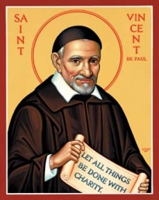 St Vincent de Paul lived 1561-1660 and pledged his life to the sick, infirm, orphans and old people, beggars, the starving and slaves. There was no form of poverty- physical, emotional or spiritual, which he did not try to make easier for others.
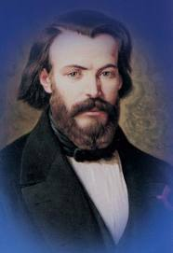 In 1833 a catholic French student called Frederick Ozanam founded the SVP society. He wanted to encourage people in the church to help the poor by putting their faith in Christ into action.
Today there are over 1 million SVP members established in 138 countries.

Why join YSVP?
. It will improve your personal record of achievement, support your application to college or university, may provide you with references for future employers.
. Voluntary Work in the community is important for your own personal and social development
. It qualifies for the ‘service’ part of schemes such as the Duke of Edinburgh Award or Trident
. It is fun and you will meet other young people and take part in fun activities and events

WHO CAN JOIN?
YSVP is open to any St Winefride’s parishioner from School Year 8 till Upper Sixth - (12-18 years old) and can attend any of the local schools. Yearly registration must be completed no later than December.

Do I have to pay?
There is no cost to joining. Members will be asked to make a contribution or donation to help with activities and events during the year, but there is no obligation to do so. It is up to you and depends on your circumstances , we just ask that you be as generous as you can with your time, your possessions and your selves.

What will you be expected to do as a YSVP member?
The main quality you need in COMMITMENT, this means always doing what you say you are going to do and try to attend all the meetings.
The main responsibilities include;

- Attending Weekly meetings.
Weekly MEETING Includes;
. Setting up for Little Church and Teas
. The President opens the meeting with a Prayer
. A short spiritual reading /reflection/meditation follows
. Group members discuss their activities since the last meeting and any plans for future events
. The president concludes the meeting with a prayer
. The Adult Helper from Little Church introduces the readings and activity
. Little Church
. Helping to provide Teas after mass

The group meets every week from September- July to plan and organise any events and to pray for the group’s intentions. At present we meet at 10am on Sunday mornings throughout the school year. The meeting usually last for 45 mins, the first 10 minutes is used to set up for Little Church and Teas . Then we have 20 minute discussion and plan forthcoming events. We also offer our work to God and ask for his help and guidance in the form of a prayer. The last 10-15 minutes is given to preparing Little Church which will have been prepared by another Adult helper. A ‘president’ or leader is elected by the youth group to lead the meeting and to organise the group. An Adult Group Advisor is linked to the group and gives help and practical advice when needed BUT the group is expected to generate the own ideas and do the all of the work.

NB Attendance
To receive your certificate of attendance members have decided that a minimum attendance of 65% is required. If you cannot attend a meeting please give your apologies in advance and give a reason for your absence, which should only be for a genuinely unforeseen or planned event. To receive your certificate of attendance all registration forms must be completed by the December of the current YSVP year.

- Fundraising for Charity.
The group will decide in September which charities it would like to support during the year - have a think if there is any charity that you would like to raise money for. We usually support at least one international, one national and one local charity, with at least one charity aimed at supporting children and young people. It must be a registered charity with aims and principles are compatible with the Christian ethos.
Over the year all members will be asked to assist in the planning and organisation of the events. Some may be asked to lead projects and be team leaders. ALL of you will be expected to help.
Some of the activities we organised so far include’ Collecting and making Christmas Shoe Boxes; Cake Sales; Sponsored walks-Mersey Moonwalk, Christian Aid Walk, Wirral Coastal; providing teas after 10-45 mass; Musical social night- Jazz band or Ceilidh Folk Dance; Fun activities for children; helping at the Christmas Fair and Summer Fair

- Providing Little Church to the 3-7 year olds
Members are asked to help with Little Church by setting up, doing the readings, interacting with the younger children by chatting to them and helping them do the planned activity, making sure that they return safely to the main church. The YSVP members are important role models to the younger children and set an example to them in the way they form relationships and by showing how to be an active member of the parish. ( see more details below)

Leading Roles
The first task in September is to choose the group’s new President, Vice president, Secretary and Recorder. You need to consider the following;
Taking on such a role can be challenging but also very rewarding and will be of interest to future colleges and employers.
You will also need to consider your other commitments too , especially exams. If it is your GSCE or A Level year at school you need to think really carefully before taking on the responsibility of a leading role.
Thinking of having a go? Here is some info that might help you decide….

President – Needs to be reliable - Most definitely needs to be present on a regular basis – able to attend on most weeks. Trustworthy – has a sensible attitude . Willing -to represent the group - at youth mass, eg, giving thanks for support from parish and meeting people from charity groups. Able to encourage other members to take part in activities, look after new members and take the lead in activities. A Leader -Someone who will use initiative to make things happen and who makes sure that things are done well.

Vice President – Needs to be reliable and Supportive - prepared to work closely with the President in making sure the planned activities go well Would appeal to someone who may consider taking on Presidents role in following year

Secretary – Takes minutes/notes and register from weekly meeting, sends letters of thanks to supporters and sends letters to charities on behalf of group. Prepared to do a report on some of the activities. A neat writer and able to express themselves well.

Recorder – Records the group’s activities in the Portfolio – taking photos, placing the info creatively in the portfolio or other displays /newletters on a regular basis. Would appeal to some on who is arty and who can display work well.

If you want to be considered for one of the above, please give your name to the Adult Leader before the first meeting in September
If there is more than one person for the position, group member will decide with a secret vote.

Social Events
As well as fundraising events the group tried to meet for a social activity at least once a year, eg in December for Ten Pin Bowling and Lazerquest. It’s an opportunity to meet informally and get to know each other in fellowship It is an important part of building a team and it is hoped that all members will take part.

Conduct.
All members are expected to behave with respect and dignity whilst carrying out activities associated with YSVP. Disrespectful behaviour and attitudes will not be tolerated and may result in membership being withdrawn
Sponsorship
If you are seeking sponsorship for non-SVP activities ( eg over-seas voluntary work such as Lourdes pilgrimage ) please ask for a our guidelines for application form.
Duke of Edinburgh Award-
If you are hoping to use you YSVP work as part of your service for D of E you MUST inform the Adult Leader BEFORE you start your Award.

Safeguarding Children
All Adults working with children must complete a CRB check in accordance with Shrewsbury Diocesan policy and have a satisfactory CRB disclosure clearance.

GUIDELINES FOR THE CHILDREN’S LITURGY

The children’s liturgy is part of the Holy Mass, which has been simplified for the younger children. It is the proclamation of God’s Holy Word and should be treated with dignity and respect.
The helpers who read the Word should speak slowly, clearly and loud enough for a child in the back row to hear.
Helpers who are not reading should remember this is part of the Mass, and should join in the prayers with the children. Please welcome the children and ensure every child has a seat and that the children are paying attention to the prayers and readings.
At 10 45am two helpers should go into church to collect the children and bring them safely into the hall. While in church waiting for Father to announce Little Church; please stand in centre of the aisle so he can see you.
The readings are divided into:
- Introduction tells them what the theme of the day’s gospel is about.
- Candle Prayer. Light the candle and read the candle prayer, which the children repeat line by line.
- Sorry Prayer Get the children to join their hands in prayer and ask them to think of the thing they have done wrong that week. Then ask them to repeat line by line the Sorry Prayer.
- Gospel Story Read clearly and slowly with some emphasis to enable the children to understand the story. If the reading is a short one repeat the reading.
- Questions and Answers. These are placed on coloured cards and the children ask to choose a card. When chosen ask the question and encourage them to answer the questions, by giving them some hints!
- Bidding prayers should be stated slowly and clearly, with the children answering each petition with the reply “Lord hear us”. Ask them if they have anyone special they want to pray for.
- Final Prayer is based on the theme of the gospel and the children are asked to repeat line by line.
- Finally make the sign of the cross.
The helper who has read the gospel shows the children the picture of the gospel story and an explanation of the picture,
Helpers please make sure that each child has a chair at the table, has crayons and a picture to colour and that they understand the picture relates to the story.
Clear away the altar and put the tables and chairs back in order.
When the procession is returning to church 2 helpers and a group leader must take the young ones back safely.
The notice board is carried by 2 children and taken down to the altar.
Other helpers please tidy up the hall. Collect all the items to be stored in the cupboard and brown chairs stacked away.
Return to church as quickly as possible for the most solemn part of the Mass the Offertory. Remember if you miss this part of the Mass you officially haven’t heard Mass.

Code of Conduct for Children and Young People

I will respect and take care of others and not hurt or frighten anyone
I will be polite to all I meet
I will respect and take care of things that belong to the parish and others
I will listen to and try to understand others' opinions
I will behave in a way that allows all to enjoy the group/activity
I will be quiet when asked to by the activity leaders

Signed…………………. Date…………………………..

Date of joining………………………………………………………………………… Year of Membership ………………………….

Name ……………………………………………………………
Address …………………………………………………….
……………………………………………………..
……………………………………………………..
Telephone Number …………………………………………….. Mobile Number …………………………………………………..
Email Address ……………………………………………………………………………………………..

Date of Birth ……………………………………………………….

School Attended …………………………………………………
School Year …………………………………………………….

Are you hoping to use your YSVP experience as part of the Duke of Edinburgh Award scheme this year? Yes No

Do you have any allergies ? NO YES ( Please give details) …………………….

Do you have any medical problems, learning difficulties or issues that you would like us to be aware of so that we can support you in your participation of the group and it’s activities?
NO…. YES (Please give details)
…………………………………………………………………………………………………………………………………………………………………………
………………………………………………………………………………………………………………………………………………………………………..

Have you read, signed and agreed to follow the Code of Conduct for Young People ? Yes No

Signature ……………………………………………

Adult Leader’s Signature …………………………………………….

Progress report;
Attendance % -
Meetings attended –
Activities participated in –
Roles taken on within group –
Personal Qualities Observed-

What Personal Qualities do you have ( or could you develop) during your time at YSVP?
Reliable
Punctual/On time
Commitment to group
Trustworthy
Tidy
Organised
Willing to participate in activities
Volunteers before being asked
Generous with their time, possessions and themselves
Interacts well with new members
Interacts well with Young Children
Interacts well with Adults
Interacts well with other group members
Communicates well verbally
Communicates well in written form
Sense of fun
Sense of humour
Considerate to and of others
Aware of the feelings of others
Respectful
Polite
Uses initiative
Creates ideas for the group
Energetic
Calm
Show’s self control
Hard working
Tries hard
Perseveres
Doesn’t give up
Responsible
Responds well to feedback from others
Prayerful
Thoughtful

Anything you would like to add??????

