**WEEKDAY MASS SHEET**



**FOURTH WEEK   
OF ADVENT**

*22nd December — 28th December 2013*

**OUR PRAYERS THIS MONTH**

*We pray especially for: Openness to the Word of God, Migrants and Refugees and Expectant Mothers.*

**THE HOLY FATHER’S INTENTIONS (December)**

***General Intention****: That children who are victims of abandonment or violence may find the love and protection they need.*

***Missionary Intention****: That Christians, enlightened by the Word incarnate, may prepare humanity for the Saviour’s coming.*

**MONDAY**

**St John of Kęty, Priest**

*Born in Kęty in Kraków in 1390. He became a priest and for many years taught at he university of Kraków; later he became parish priest of Olkusz. He taught and researched in both physics and theology and excelled in holiness and in charity towards his neighbour, in which he was an example to his colleagues and pupils. He died in 1473.*

*Entrance Antiphon:* **A child shall be born for us, and he will be called God, the Almighty; every tribe of the earth shall be blest in him.**

*First Reading*: Malachi 3: 1–4. 23-24

*I am going to send you Elijah the prophet before the day of the Lord comes.*

*Responsorial Psalm:* **Stand erect, hold your heads high, because your liberation is near at hand.**

*Gospel Acclamation:* **Alleluia, Alleluia! King of the peoples and corner-stone of the Church come and save man whom you made from the dust of the earth. Alleluia!**

*Gospel*: Luke 1: 57-66

*The birth of John the Baptist.*

*Communion Antiphon:* **Behold, I stand at the door and knock: if anyone hears my voice and opens the door to me, I will enter his house and dine with him, and he with me.**

**TUESDAY**

**Weekday**

*Entrance Antiphon:* **Behold, when the fullness of time had come, God sent his Son into the world.**

*First Reading*: 2 Samuel 7: 1-5. 8-12.14.16

*The kingdom of David will always stand secure before the Lord.*

*Responsorial Psalm:* **I will sing forever of your love, O Lord.**

*Gospel Acclamation:* **Alleluia, Alleluia! Morning star, radiance of eternal life, sun of justice, come and enlighten those who live in darkness and in the shadow of death. Alleluia!**

*Gospel*: Luke 1: 67-79

*Our God from on high will bring the rising Sun to visit us.*

*Communion Antiphon:* **Blessed be the Lord, the God of Israel! He has visited his people and redeemed them.**

**WEDNESDAY**

**(The Nativity of our Lord)**

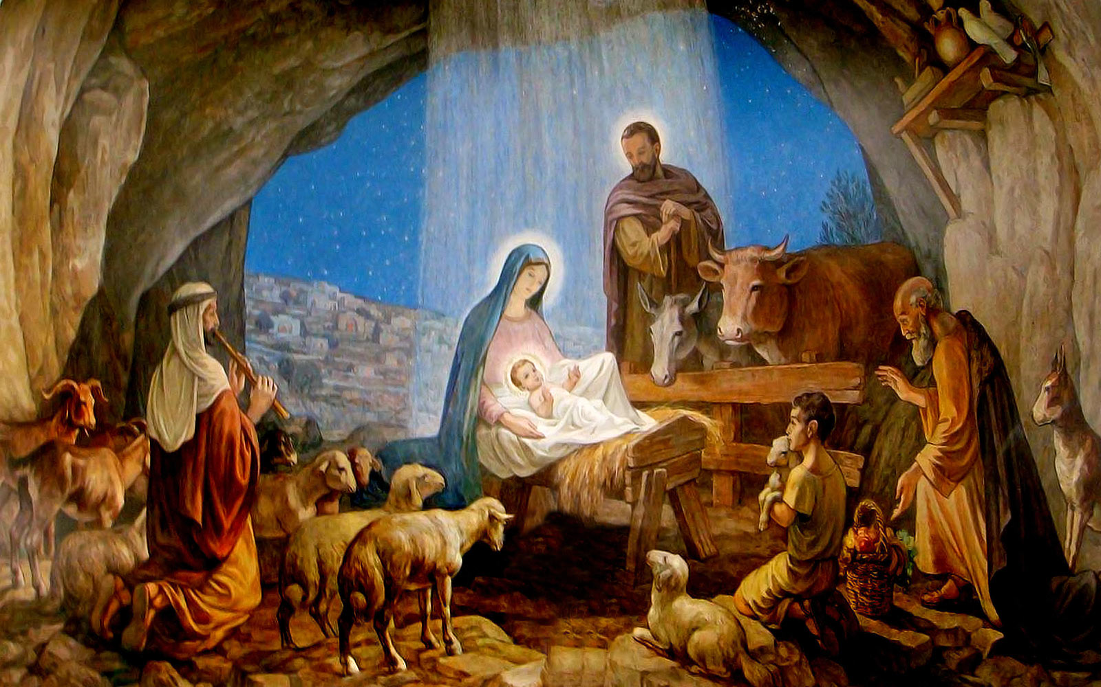

**THURSDAY**

**St Stephen, First Martyr**

*St Stephen was one of the deacons appointed by the apostles to organise the distribution of food to the poor. He performed many miracles and confounded the Jews in disputation. They fabricated false charges against him. AT his trail he preached the risen Christ to them, so they stoned him to death. He prayed for his persecutors as he was dying. One of them, Saul of Tarsus, who was looking after the cloaks of the stone throwers, was later converted and became the great missionary St Paul.*

*Entrance Antiphon:* **The gates of heaven were opened for Blesed Stephen, who was found to be first among the number of the martyrs and therefore is crowned triumphant in heaven.**

*The Gloria is said*

*First Reading*: Acts 6 :8-10. 7: 54-59

*I can see heaven thrown open.*

*Responsorial Psalm:* **Into your hands, O Lord, I commend my spirit.**

*Gospel Acclamation:* **Alleluia, Alleluia! Blessed is he who comes in the name of the Lord; the Lord God is our light. Alleluia!**

*Gospel*: Matthew 10: 17-22

*You will be dragged before governors and kings for my sake, to bear witness before them and the pagans.*

*Communion Antiphon:* **As they were stoning Stephen, he called out: Lord Jesus, receive my spirit.**

**FRIDAY**

**St John   
Apostle and Evangelist**

*James and John, sons of Zebedee, where nicknamed “the sons of thunder” by Jesus. The fourth gospel, three epistles and the apocalypse are attributed to him. He witnessed the transfiguration; and was present at the foot of the cross - where Jesus entrusted the care of his mother to him.*

*Entrance Antiphon:* **This is John, who reclined on the Lord’s breast at supper, the blessed Apostle, to whom celestial secrets were revealed and who spread the words of life through all the world.**

The Gloria is said

*First Reading*: John 1: 1-4

*What we have seen and heard we are telling you.*

*Responsorial Psalm:* **Rejoice, you just, in the Lord.**

*Gospel Acclamation:* **Alleluia, Alleluia! We praise you, O God, we acknowledge you to be the Lord. The glorious company of the apostles praise you, O Lord. Alleluia!**

*Gospel*: John 20: 2-8

*The other disciple, running faster than Peter, reached the tomb first.*

*Communion Antiphon:* **The Word became flesh and made his dwelling among us, and from his fullness we have all received.**

**SATURDAY  
The Holy Innocents, Martyrs**

*This day commemorates the slaughter, by Herod, of all children under the age of two in Bethlehem at the time Jesus was born.*

Entrance Antiphon: **The Innocents were slaughtered as infants for Christ; spotless, they follow the Lamb and sing for ever, Glory to you, O Lord.**

*The Gloria is said*

*First Reading:* John 1: 5-2:2

*The blood of Jesus Christ purifies us from all sin.*

*Responsorial Psalm:* **Our life, like a bird, has escaped from the snare of the fowler.**

*Gospel Acclamation:* **Alleluia, Alleluia! We praise you O God, we acknowledge you to be the Lord. The noble army of martyrs praise you, O Lord. Alleluia!**

*Gospel:* Matthew 2: 13-18

*In Bethlehem Herod had all the male children killed.*

*Communion Antiphon:* **Behold those redeemed as the first fruits of the human race for God and the Lamb, and who follow the Lamb wherever he goes.**

