**WEEKDAY MASS SHEET**

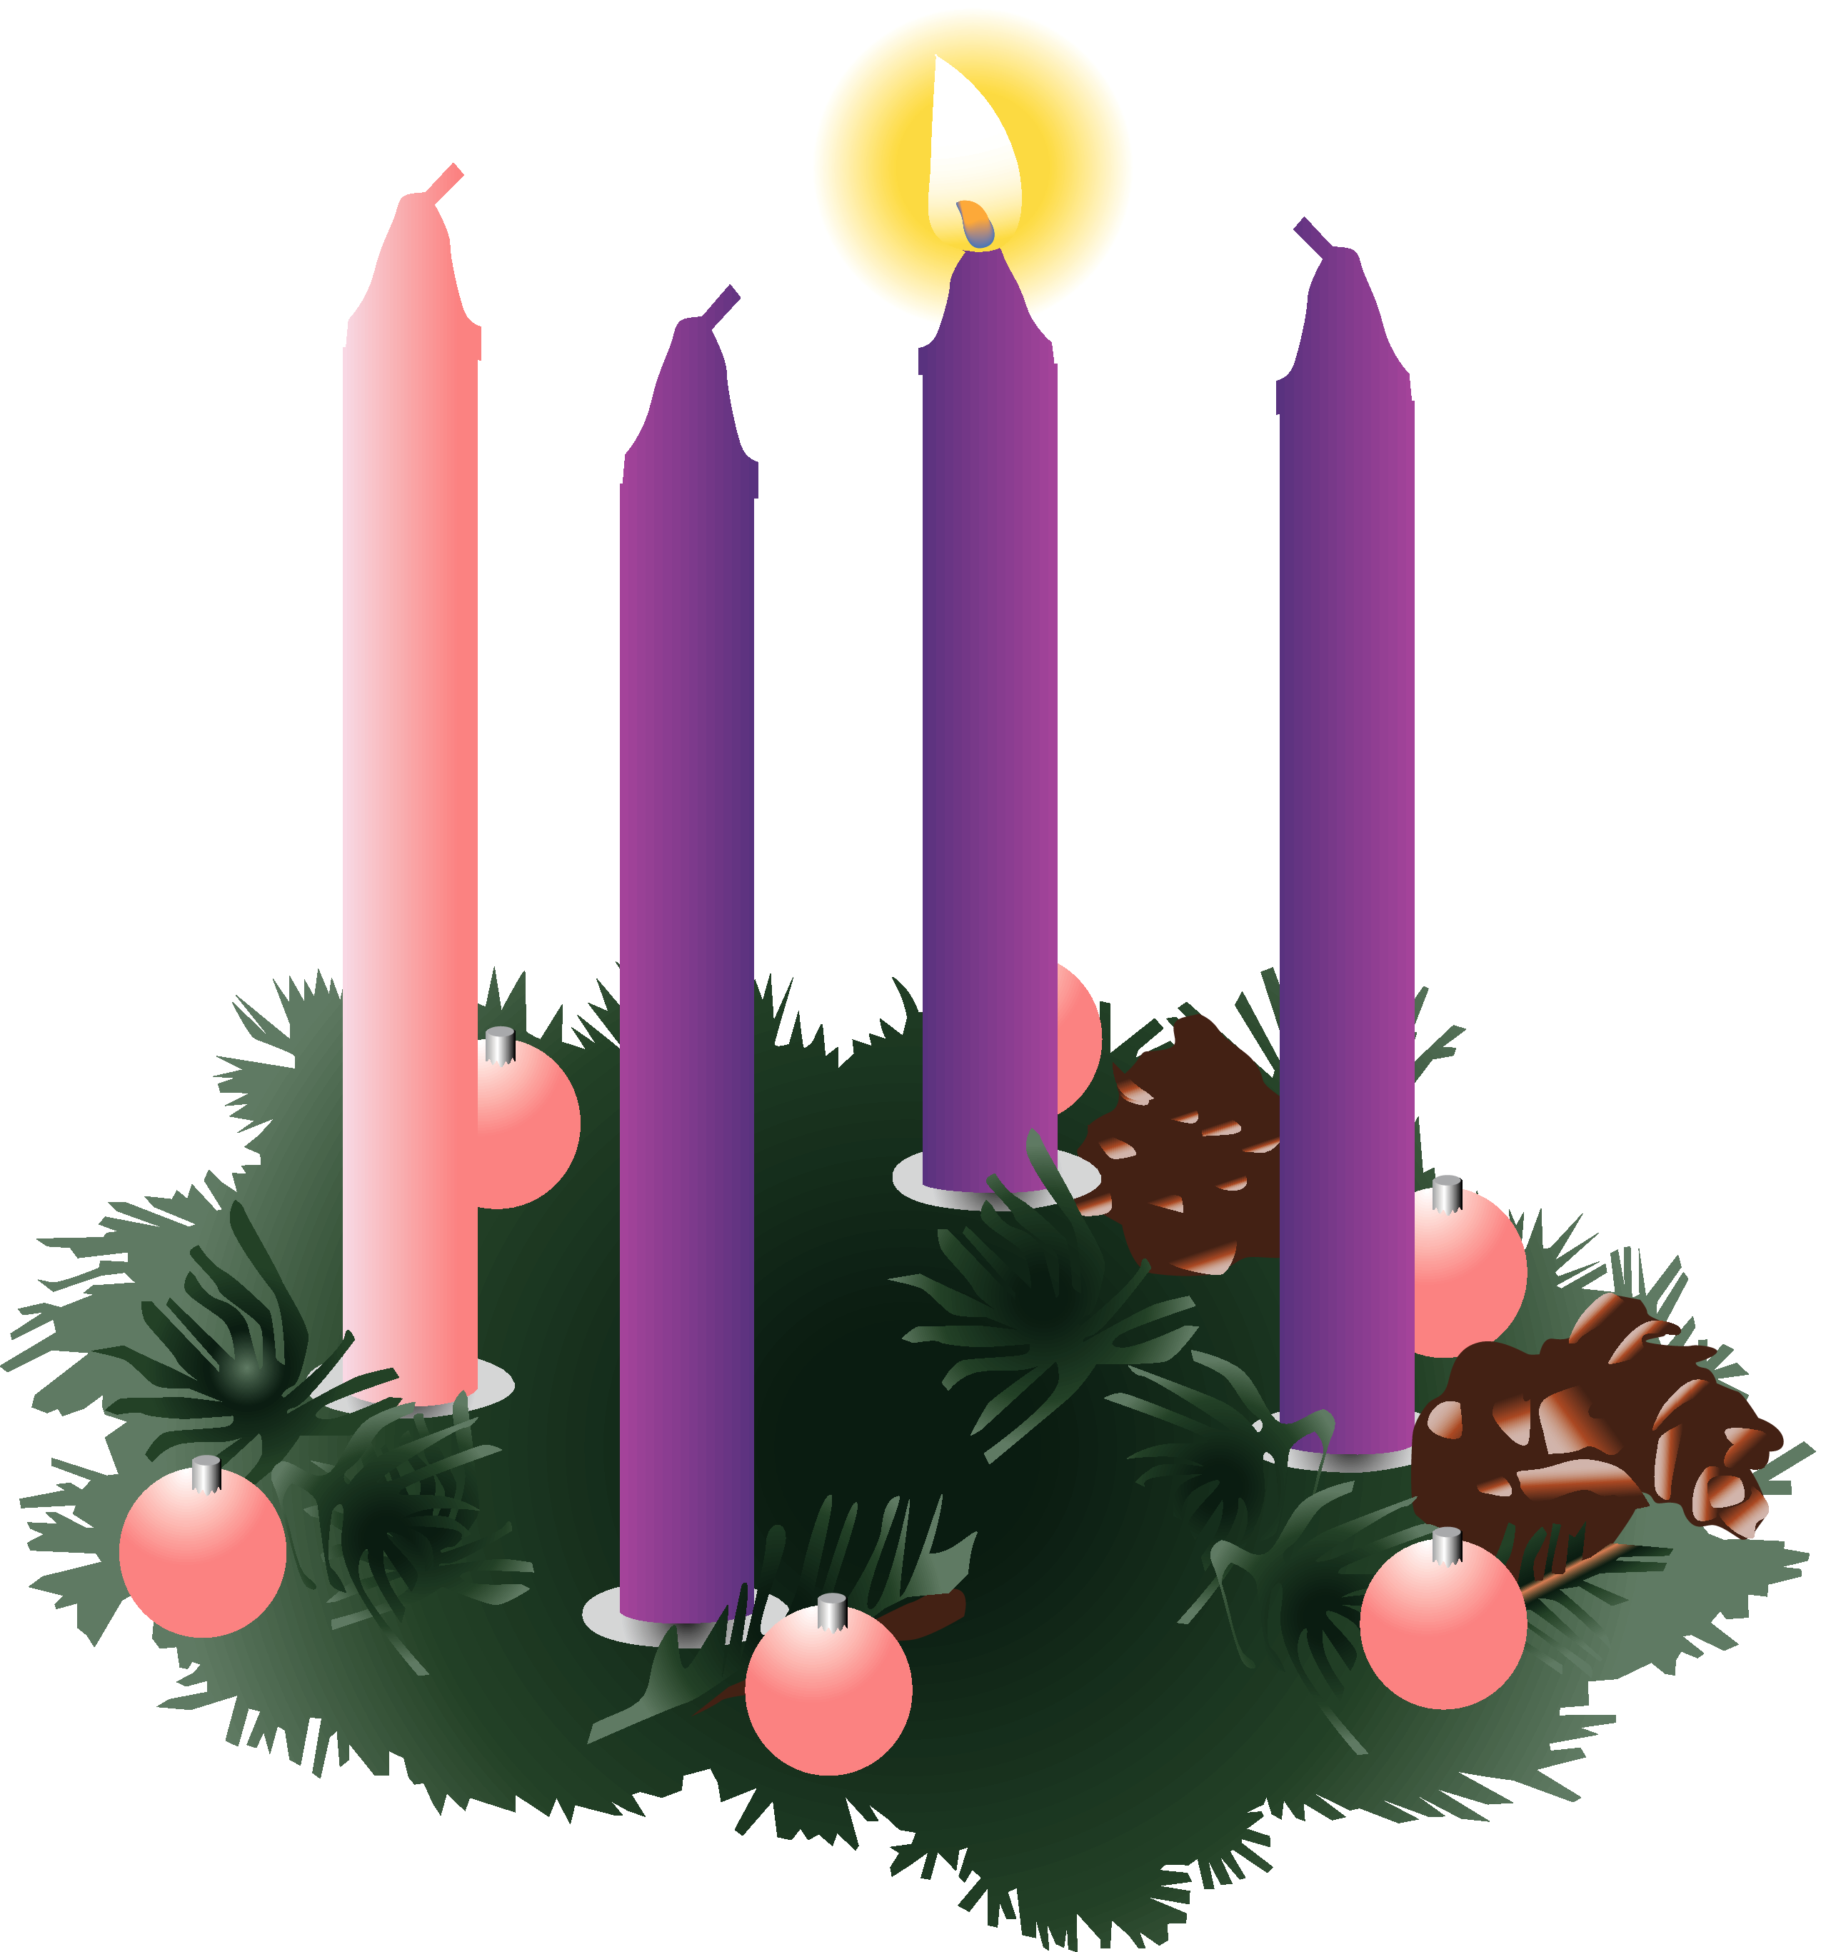

**FIRST WEEK OF ADVENT**

*1st December — 7th December 2013*

**OUR PRAYERS THIS WEEK**

*We pray especially for: Openness to the Word of God, Migrants and Refugees and Expectant Mothers.*

**THE HOLY FATHER’S INTENTIONS (December)**

***General Intention****: That children who are victims of abandonment or violence may find the love and protection they need.*

***Missionary Intention****: Christians, enlightened by the Word incarnate, may prepare humanity for the Saviour’s coming.*

**MONDAY**

**Weekday**

*Entrance Antiphon:* **Hear the word of the Lord, O nations; declare it to the distant lands: Behold, our saviour will come; you need no longer fear.**

*First Reading*: Isaiah 4:2-6

*The fruit of the earth shall be the pride and adornment of Israel’s survivors.*

*Responsorial Psalm:* **I rejoiced when I heard them say: “Let us go to God’s House.”**

*Gospel Acclamation:* **Alleluia, Alleluia! God of Hosts, bring us back: let your face shine on us and we shall be saved. Alleluia!**

*Gospel*: Matthew 8:5-11

*Many will come from east and west to take their places in the kingdom of heaven.*

*Communion Antiphon:* **Come, O Lord, visit us in peace, that we may rejoice before you with a blameless heart.**

**TUESDAY**

**Saint Francis Xavier, Priest**

*Born in Spain in 1506 .Whilst studying in Paris he met St Ignatius of Loyola. He became one of the first Jesuits and tirelessly brought the Gospel to India, Borneo, Indonesia and Japan. He died of fever on Shangchuan Island in 1552 while travelling to China.*

*Entrance Antiphon*

**I will praise you, Lord, among the nations; I will tell of your name to my kin.**

*First Reading*: Isaiah 11: 1-10

*On him the spirit of the Lord rests.*

*Responsorial Psalm*

**In his days justice shall flourish and peace till the moon fails.**

*Gospel Acclamation*

**Alleluia, Alleluia! Let us see, O Lord, your mercy and give us your saving help.Alleluia!**

#

*Gospel*: Luke 10: 21-24

*Jesus is filled with joy by the Holy Spirit.*

*Communion Antiphon*

**What I say to you in the darkness speak in the light, says the Lord, what you hear whispered, proclaim on the housetops.**

**WEDNESDAY**

**St John of Damascus  
Priest and Doctor of the Church**

*Born in Damascus (Syria) under Muslim rule, became a monk in the monastery of St Sabbas near Jerusalem. He wrote theological works and hymns including The Day of Resurrection. He was declared a Doctor of the Church in 1890.*

*Entrance Antiphon*

**The Lord will come and he will not delay, and he will not delay. He will illumine what is hidden in darkness and reveal himself to all the nations.**

*First Reading:* Isaiah 25:6-10

*The Lord invites us to his banquet and wipes away the tears from every cheek.*

*Response to the Psalm*

**In the Lord’s own house shall I dwell for ever and ever.**

*Gospel Acclamation*

**Alleluia, Alleluia! The Lord is our judge, the Lord our law giver, the Lord our king and our saviour. Alleluia!**

*Gospel:* Matthew 15:29-37

*Jesus cures many and multiples the loaves.*

*Communion Antiphon*

**Behold, our Lord will come with power, and will enlighten the eyes of his servants.**

**THURSDAY**

**Weekday**

*Entrance Antiphon*

**You, O Lord, are close, and all your ways are truth. From of old I have known of your decrees, for you are eternal.**

*First Reading*: Isaiah 26:1-6

*Let the upright nation come in, she, the faithful one.*

*Response to the Psalm*

**Blessed in the name of the Lord is he who comes.**

*Gospel Acclamation*

**Alleluia, Alleluia! Shout with a loud voice, joyful messenger to Jerusalem. Here is the Lord God coming with power. Alleluia!**

*Gospel*: Matthew 7:21. 24-27

*The person who does the will of my father will enter the kingdom of heaven.*

*Communion Antiphon*

**Let us live justly and devoutly in this age, as we await the blessed hope and the coming of the glory of our great God.**

**FRIDAY**

**Saint Nicholas, Bishop**

*Born in Turkey (fourth century) and became Bishop of Myra. He may have attended the council of Nicaea which opposed the Arian heresy. Nicholas’ reputation for generosity led to the custom of giving children gifts on his feast day.*

*Entrance Antiphon*

**Behold, the Lord will come descending with splendour to visit his people with peace, and he will bestow on them eternal life.**

*First Reading*: Isaiah 29:17-24

*That day the eyes of the blind will see.*

*Response to the Psalm*

**The Lord is my light and my help.**

*Gospel Acclamation*

**Alleluia, Alleluia! Send victory like a dew, you heavens, and let the clouds rain it down. Let the earth open and bring forth the saviour. Alleluia!**

*Gospel*: Matthew 9:27-31

*Two bind men who believe in Jesus are cured.*

*Communion Antiphon*

**We await a saviour, the Lord Jesus Christ, who will change our mortal bodies, to conform with his glorified body.**

**SATURDAY**

**St Ambrose  
Bishop and Doctor of the Church**

*Son of a Roman prefect, he was born in c.340 and worked as a lawyer in Milan. In 374 he was chosen to be Bishop of Milan despite not having been baptised. He proved to be an outstanding bishop and was uncompromising in the struggle against Arianism. His converts included St Augustine and his teachings have led him to be numbered as one of the Latin doctors of the church.*

Entrance Antiphon

**In the midst of the church he opened his mouth, and the Lord filled him with the spirit of wisdom and understanding, and clothed him in a robe of glory.**

*First Reading:* Isaiah 30:19-21.23-26

*He will be gracious to you when he hears your cry.*

*Response to the Psalm*

**Happy are all who hope in the Lord.**

*Gospel Acclamation*

**Alleluia, Alleluia! See the Lord while he is still to be found, call to him while he is still near. Alleluia!**

*Gospel:* Matthew 9:35 - 10:1.6-8

*When he saw the crowds he felt sorry for them.*

*Communion Antiphon*

**Behold, I am coming soon, and my recompense is with me, says the Lord, to bestow a reward according to the deeds of each.**

